**ATM MANAGEMENT SYSTEM**

**MINOR PROJECT REPORT**

**Submitted by**

**NAZMI INSHAAL**

**Roll No. 1504038**

**BCA V SEMESTER**

**I would like to express my special thanks of gratitude**

**Under the guidance of**

**DR. MAZHAR KHALIQUE.**

**Khwaja Moinuddin Chishti Urdu,Arabi-Farsi**

**University, LUCKNOW**

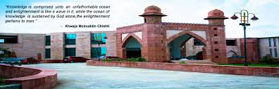

**ACKNOWLEDGEMENT**

The satisfaction that accompanies that the successful completion of any task would be incomplete without the mention of people whose ceaseless cooperation made it possible, whose constant guidance and encouragement crown all the effort with success.

I am very grateful to our Project Leader, for giving me an opportunity to work on this project and showing the confidence in me for the proper execution of the project.

I would also like to thank **Dr. Mazhar Khalique** (H.O.D of Computer Application Department), KMC-UAF University who provide us the mental support and motivated us at every walk of our project.

Secondly I would also like to thank my parents and friends who helped me a lot in finalizing this project within the limited time frame.

I am making this project not only for marks but to also increase my knowledge.

THANKS AGAIN TO ALL WHO HELPED ME.

**Nazmi Inshaal**

**Roll No. 1504035.**

**Project on ATM Banking Management System**

**1. Introduction**

ATM Banking Management system is a well-planned system designed in order to provide well structured mechanism to store record of all customers of the bank. The process from account opening to balance enquiry all is performed on the software solution provided by our project.

This proposed application will manage all the needs from both ends from Customer end as well as from management end. By using this application any bank can manage its all on going processes and also can generate reports that are very much important and fruitful in the growth of organization

**2. Objective**

This application would help very much keeping record about all customers, their personal information, whole transaction which they have performed in a given duration etc. All the record would be kept in a database and which would be available on just a single click.

Every branch would be able to know about how many accounts were opened in a given duration, how many fixed deposits were done etc. It becomes very much easy for the management to generate customized reports on the basis of their requirement.

**3. Feature and Available Information**

There are mainly one in the project-

**3.1 Customer**

**3.1 Customer Features**

**a) Login**

**b) Check Balance**

**c) Withdraw Amount.**

**d) Change Password**

**Other Features described in Future Scope.**

**4. System Analysis**

System analysis is the main features of the software development. It can be said that it is the heart of any of the system. The analysis needs an expert supervision and person should be minimum System analysis with experience of 3 to 5 years. One can use Analysis tools to analyze the system.

Some of the tools we have used to analyze the problem is given below,

**4.1 Analysis Tools**

**4.1.1 Data Collection Tools:**

In order to get the information for our proposed application we approached the

**Analyze InfoTech**, and collected the information related to our application. This was necessary to make general software, which can be used by any Business/Organization.

**4.1.2 Charting Tools**

The graphical Representation of system and activities help us to understand the minor problems and the flow of information very easily, which can become very helpful in analysis as well as to generated the new systems requirement. Graphical representation is always better than normal text. We made E-R diagram and Data Flow Diagram to collect all the information and build relationship among the external entities. In order to understand the flow of information in the system the Data Flow Diagram plays a very important role. E-R Diagram are used to convert the entities and relationship in the relational tables.

**4.1.3 Dictionary Tool**

This tool helps us to maintain and record the data & description of system element through data items, Processes and data sources. This basically helps us about the information flow among various units.

**4.2 Identification of Need**

Goal of analysis hear is recognition of the basic problem elements as perceived by the top management as well as Business administrator and understand application in the system context. In order to identify the need, there is a need to establish contact with various Business staff and software development organization.

**4.3 Feasibility Study**

All projects are feasible given unlimited resources and infinite time! Unfortunately, the development of computer based system is more likely to be plagued by a scarcity of resources and difficult delivery dates. It is both necessary and prudent to evaluate the feasibility of the project at the earliest possible time. Months or years of effort, Money loss and untold professional embarrassment can be averted I few better understand the project at its study time.

This type of study determines if an application can and should be developed. Once it has been determining that, application is feasible. After that analyst can go ahead and prepares the project specification, which finalizes project requirements. Feasibility studies are undertaken within tight time constraints.

The developed system is started after considering the main three types of feasibilities that are discussed below :-

**5. Design**

Software Design is the first of three technical activities design, coding and testing that are required to build and verifies software. The flow of information during this technical phase of the software requirement, manifested by information, functional and behavioral models feed the design step. Using one of a number of

design methods the design step produces a data design, an architectural design and a procedural design. The data design transforms the information domain model created during analysis into the data structures that will be required to implement the software. The architectural design defines the relationship among major structural components of the programs. The procedural design transform structural component into a procedural description of the software. Source code is generated and testing is conducted to integrate and validate the software.

Software design is the process through which requirement are translated into a representation of software. From a project management point of view, Software design is conducted in two steps

* **Preliminary Design**
* **Detail Design**

Designing of this software is done with high cohesiveness i.e. there is minimum interaction between two different modules. There is no intra modular relationship between modules. Most of the modules are self-independent. At same time modules are loosely coupled i.e. inter modular relation exists.

Designing part includes its data flow diagrams, Database Tables and process logic of each and every modules, input design and output design. Input design includes input screens such as Business Login screen, Business Registration Screen,

**DFD**

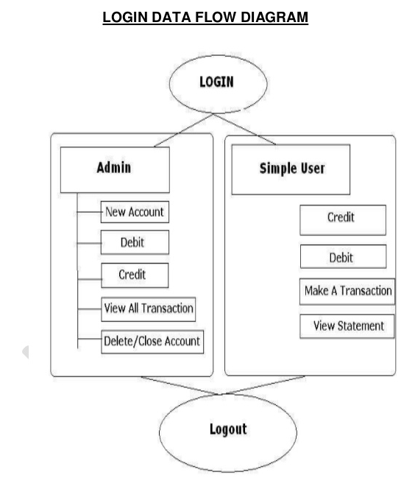

**Zero Level DFD**

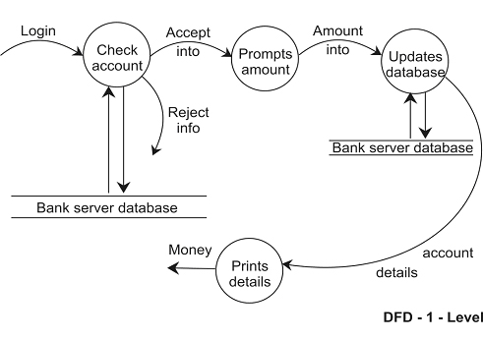

**ER DIAGRAM**

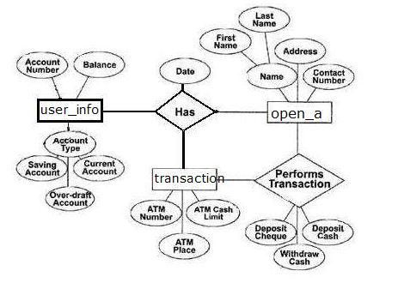

**7. Database Design**

**7.1. OPEN Account Table**

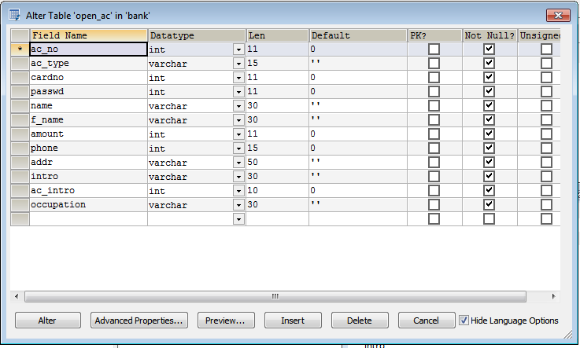

**Tools/Platforms & Software**

|  |  |
| --- | --- |
| Platforms: | Windows10/Linux |
| For Application Development: | JDK1.8, NetBeans 8.2 |
| Database Application: | My SQL |

**Hardware Requirement**

* **Pentium IV Processor**
* **512 MB RAM**
* **40 GB HDD**
* **Color Monitor**
* **Keyboard, Mouse**

**8.0 Snap Shots**

A user interface is a means by which a user interacts with an application. On the other hand GUI based software provides a graphical interface for interaction with an application. GUI are easy to learn and use as one do not have to remember any command or syntax. Most of the command can be executed using the mouse.

Input screen are designed using Java and Netbeans 8.2. We have used procedure and function to increase reusability of code

**PINCODE VERIFICATION PANEL , ATM MENU**

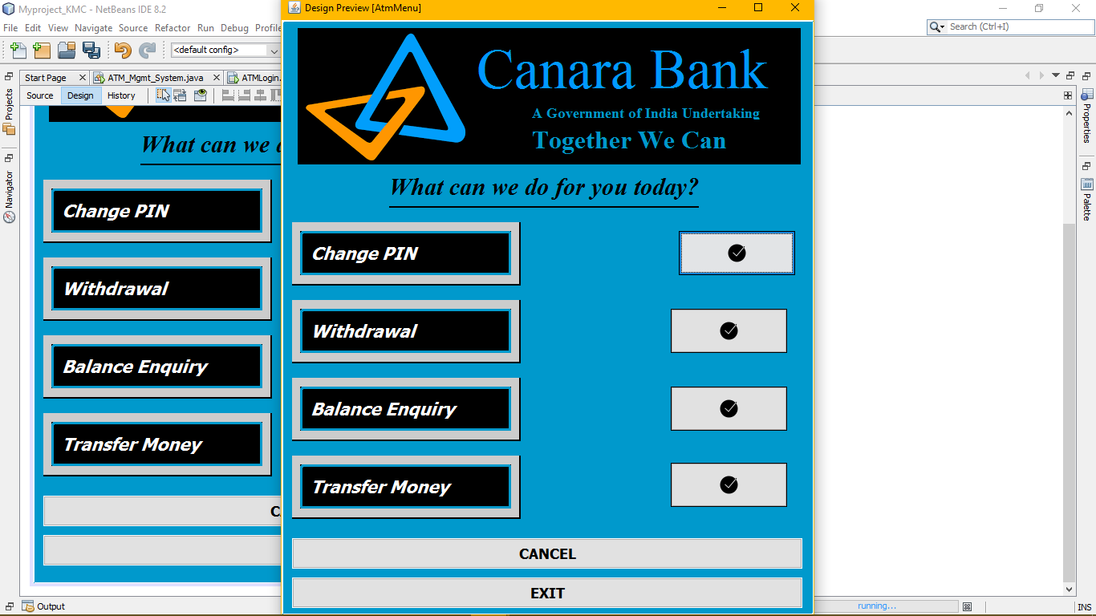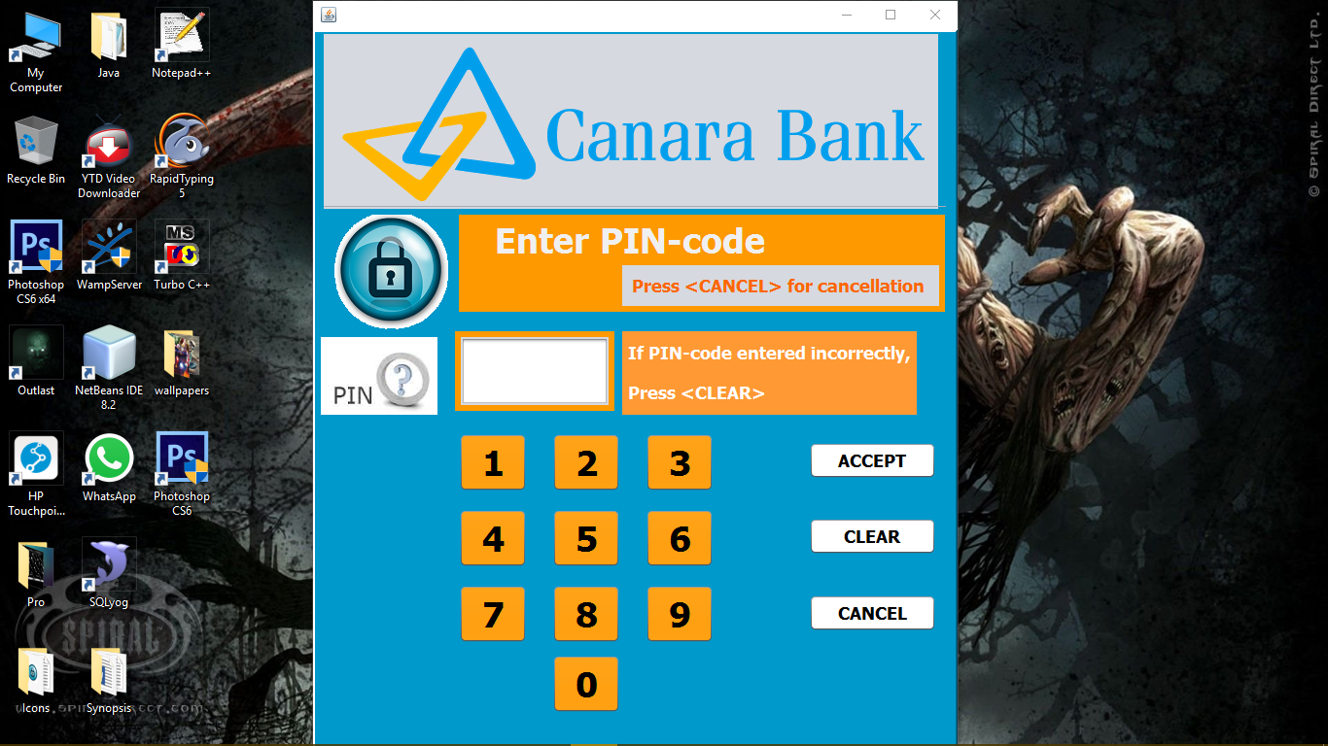

**CHANGE PIN AND BALANCE ENQUIRY PANEL**

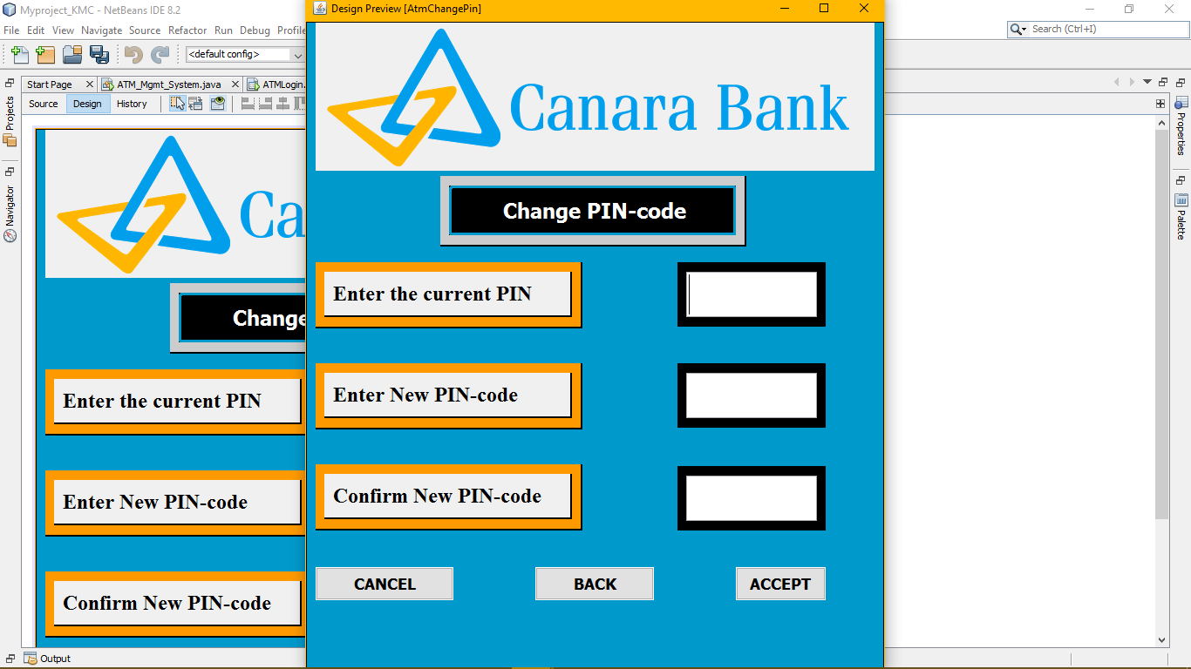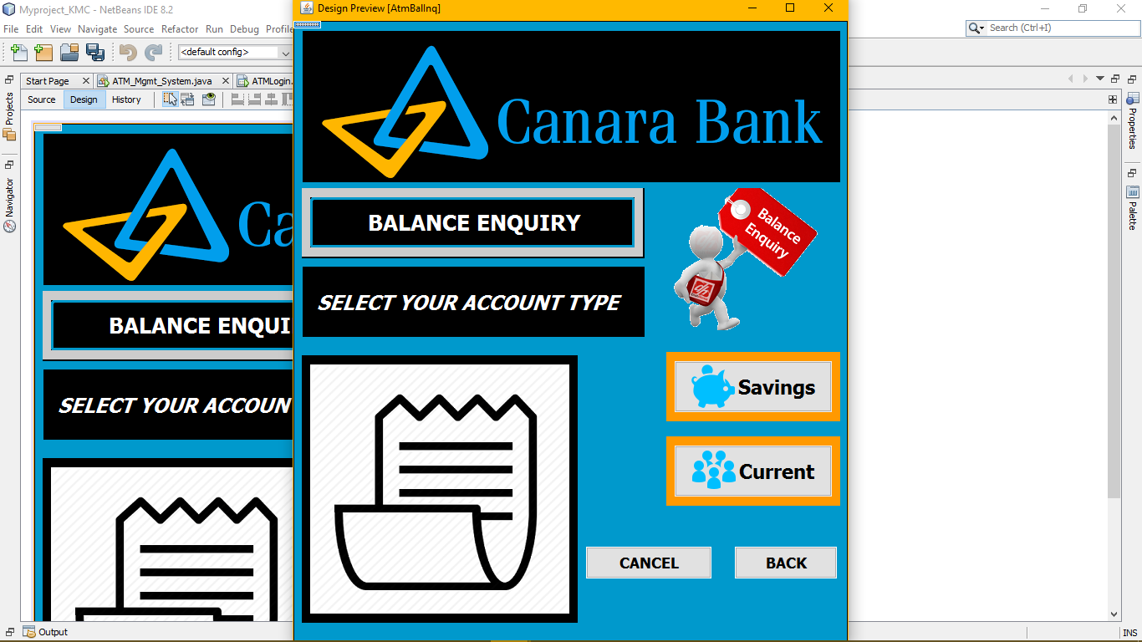

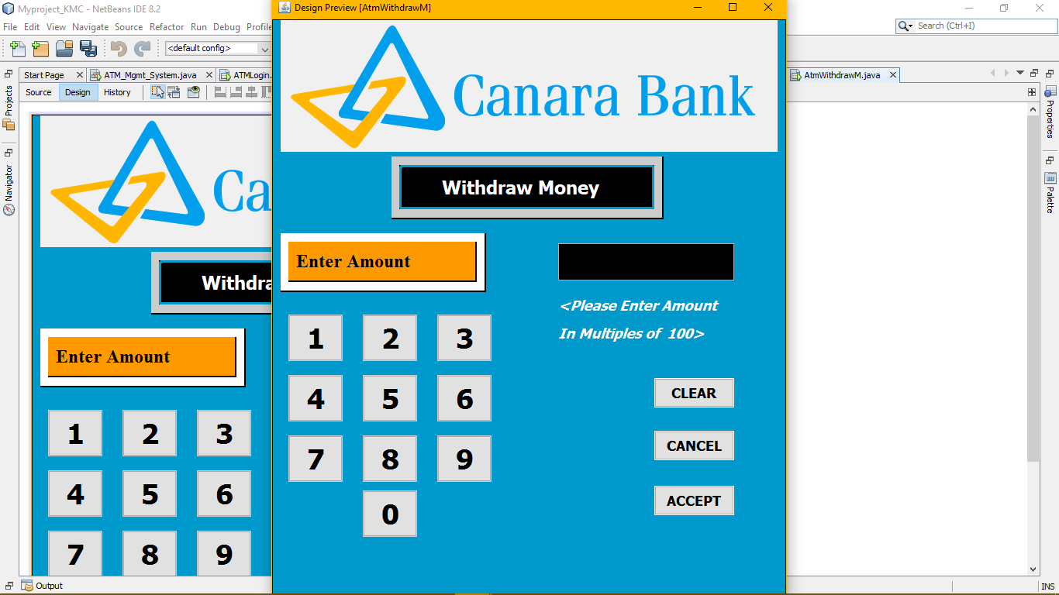**WITHDRAW PANEL**

**FUTURE SCOPE:**

**1. Performance can be increased in terms of Speed and Memory.**

**2. A Speaking voice alarm can be used to indicate unauthorized person accessing the ATM.**

**As well as some more Features:**

**3. Mini Statement**

**4. Transfer Fund**

**5. Mobile Registration**

**6. Fast Cash Deposit**

**CONCLUSION:**

**The project on ‘ATM’ management system has been developed as the best flexible and efficient project within the available resources and time.**

**In future we are planning to add new features which is described above in future scope for user more features availability.**

**Care has been taken at each step to make it more user friendly so that users can add new features where ever necessary while using this automated teller system. It may be Enhanced for Requirement of user.**